Proposal For rejuvenation and advancement of Houseblock 7 -   
for the betterment of the custodial and rehabilitation environment

John Saunders

HMP / YOI Moorland

Bawtry road

Hatfield Woodhouse

Doncaster

DN7 6BW

### Background

***The environment on Houseblock Seven has long needed updating. The colour scheme is dull and the lighting is far from pleasant. This in turn makes the unit look miserable, unwelcoming and dirty.***

***The unit is used for a number of things the first being the induction process and presents a poor first impression to anyone who arrives on the unit be it Prisoners, Staff or visitors from related organisations.   
Secondly it is used for the Care and Keep Safe of venerable individuals who are in times of crisis and in need of a welcoming, safe, friendly and caring environment.***

***There are a number of prisoners and staff who work and live on the unit full time this presents a problem in the fact there is no natural daylight or flow of air on the majority of the unit and can lead to numerous health condition which we believe have gone unnoticed and are not without concern to the majority of the staff working on the unit.***

***The artificial light is potentially detrimental when not combined with natural light to a person’s health. This could lead to such disorders as Vitamin D deficiency, 30% rise in the chance of Depression, long term sickness, loss of productivity, Sleep disorders and Decline of Cognitive Function, Increase in BMI , Migraine’s or headaches, and according to the Harvard School for Public Health it can cause a dramatic increase in the potential to contract***  ***osteoporosis, heart disease, some cancers, infectious diseases and even the flu.***

### Colour Scheme

***After being issued with a Colour Design PDF we have consulted a selection of prisoners and the staff that work on Houseblock Seven and have come to an agreement that Y3 Group scheme 37 would be the most favoured and brightest of the selections.***

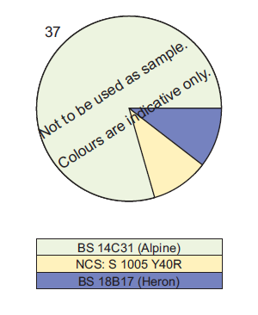

***The Colours chosen also represent particular psychological qualities that may be found to be beneficial to the unit and the prisoners and staff who spend a large proportion of their time in the environment.***

***Blue – Intellectual - Intelligence, communication, trust, efficiency, serenity, duty, logic, coolness, reflection and calm.***

***Blue is the colour of the mind and is essentially soothing; it affects us mentally, rather than the physical reaction we have to red. Strong blues will stimulate clear thought and lighter, soft blues will calm the mind and aid concentration. Consequently it is serene and mentally calming. It is the colour of clear communication. Blue objects do not appear to be as close to us as red ones. Time and again in research, blue is the world's favourite colour.***

***Yellow – Emotional - Optimism, confidence, self-esteem, extraversion, emotional strength, friendliness and creativity.***

***The yellow wavelength is relatively long and essentially stimulating. In this case the stimulus is emotional, therefore yellow is the strongest colour, psychologically. The right yellow will lift our spirits and our self-esteem; it is the colour of confidence and optimism.***

***White - Positive: Hygiene, sterility, clarity, purity, cleanness, simplicity, sophistication and efficiency.***

***White is total reflection. In effect, it reflects the full force of the spectrum into our eyes. Thus it also creates barriers, but differently from black. It communicates, "Touch me not!" White is purity and, like black, uncompromising; it is clean, hygienic, and sterile. Visually, white gives a heightened perception of space.***

Lighting

***To address the lighting issue and to reduce the potential detrimental health effects I have conducted extensive research on the type of lighting that could be used to avert some of the conditions presented in the background information.***

***A Recent study by Dr Laura Davidson mental health barrister and trustee of MHRUK, said:***

***“It is estimated that ONE MILLION working hours are lost each year due to SAD.***

***"The common unhealthy work culture where lunch breaks are frowned upon is a likely contributor to the increasing numbers of SAD sufferers.***

***"Employers and educational establishments need to take on board just how important natural light is to good mental health.***

***"They have a responsibility to ensure that work and study environments have sufficient windows to flood the building with as much natural light as possible.***

***“Darker areas must be well-lit to address the negative effects of light deprivation.”***

***To This end I have sourced a Lighting alternative that will fit into the existing fitting without the need for modification as a preventative measure to guard against the onset of the listed disorders due to the deficiency of natural light.***



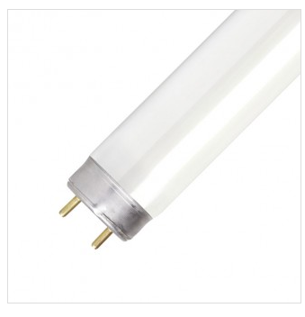

***The 36W Sylvania T8 S.A.D. Fluorescent Tube has a useful role to play in treating or preventing Seasonal Affective Disorder, which is a form of depression associated with lack of daylight exposure during winter. This Sylvania tube crucially emulates daylight in three ways: overall colour temperature, colour rendering, and UV radiation (safe levels only).***

***This great-value tube is an ideal choice for office or home areas with poor natural lighting, and fits directly into existing T8 fluorescent fittings. It emits 2850 lumens of cool white 6500K ‘daylight’ illumination, and radiates across all or most wavelengths of the visible spectrum for an incredible CRI 98 colour rendering score. A long 20,000 hour lifespan ensures years of low-maintenance use.***

***Aside from alleviating S.A.D. symptoms, the Sylvania T8 S.A.D. Fluorescent Tube promotes a feeling of well-being even amongst non-sufferers. Its natural light reduces the likelihood of eyestrain and headaches and boosts energy and concentration levels. This lamp is also a superb choice for colour-critical environments such as art studios, print shops, photo labs, graphic design houses, beauty and hair salons, or retail.***

***The dimmable 36W Sylvania T8 S.A.D. Fluorescent Tube uses a 2-pin G13 cap for connection.***

***Dimensions***

***The dimensions of the 36W Sylvania T8 S.A.D. Fluorescent Tube are:***

***•Length: 1200mm***

***•Diameter: 26mm***

***This particular lighting solution would cost***

* ***£6.36EX VAT. Per tube***
* ***Has an operating life expectancy of 20,000 hours without degradation.***
* ***Which in an increase of 5000 hours compared to the standard GE T8 Tube representing a 208 day extension to the life expectancy.***

***The above information would potentially save the prison service a substantial amount of money year on year in sickness and lost productivity.***

***The link for the tubes is below.  
http://www.lyco.co.uk/osram-t8-s-a-d-fluorescent-tube-36w.html#collateral-tabs***

Posters and Decoration

***After reading numerous Articles, research documents, case studies and published documentation the evidence is irrefutable that colour works, and the lack of colour can cost you the ability to communicate your message effectively or reach your audience at all.***

***The induction process is possibly one of the most important transition periods a person will go through in prison life especially if it’s their first time in prison.***

***We are presented with a unique opportunity to capture their attention and firstly find out if there are any immediate problems and secondly to communicate out objectives and what we expect from them during their stay with us.***

***There are numerous information posters around the unit which prisoners can draw information from, unfortunately in the majority of cases prisoner miss these posters because the posters are either black and white or grayscale.***

***We are missing capturing the audience we have been given and potentially missing an ideal opportunity to inform that audience of what we aim to achieve and what is available to them.***

***Below is some relevant information form case studies and Published works that will lay out the basis of my claim and show why we should use the sensory perception of colour and its related emotional responses to convey our message clearer and louder than ever***

An important aspect in successful and efficient cognitive functioning is the abilities to utilize the system to the fullest. Research on memory has provided a vast strategy that can be used to ensure successful retrieval.   
There appears to be a basis for associating colour and its significant effect on memory abilities. In other words, colour has the potential to increase chances of environmental stimuli to be encoded, stored, and retrieved successfully. The choice of colours and the manipulative aspects can, however, influence the extent to which colours can influence human memory performance.

Arousal, especially emotional arousal, can play an essential role in keeping the information in the memory system. Colours can enhance the relationship between arousal and memory. Kaya and Epps, asked their 98 college student volunteers in public institutions to associate colours with emotion. It was found that the majority of participants associated green colour with the feeling of calmness, happiness, comfort, peace, hope, and excitement.   
Black colour was associated with the feeling of sadness, depression, fear, and anger. This means that colours have an emotional arousing effect. However, the degree of arousal level may differ depending on the type of emotion or feeling being attached to it.   
According to Jackson, Wu, Linden, and Raymond, some types of emotion may have a greater effect on arousal than the others. For instance, anger was found to have a greater arousal effect than happy or neutral type of emotion. Red colour is being attached with stronger emotion or feeling compared to the other type of colours. Based on the studies mentioned, it shows that colour can produce an emotional arousing effect but the degree or range of arousal varies depending on the emotional element that is attached with specific type of colour.

Colour helps us in memorizing certain information by increasing our attentional level. The role played by colour in enhancing our attention level is undisputable. The more attention focused on certain stimuli, the more chances of the stimuli to be transferred to a more permanent memory storage.   
As stated earlier, colours have the potential to attract attention. Farley and Grant, were among the earliest who came out with a theory suggesting that colours have a greater effect on attention.   
This conclusion was based on their study on attention and cognition. They compared colour and no colour multimedia presentations on memory performance.   
It was reported that the coloured multimedia presentation resulted in better attention than the non-coloured presentation. Greene, Bell, and Boyer, further explained that warm types of colours such as yellow, red and orange have been found to have a greater effect on attention compared to the cool type of colours like brown and grey.

Colour Increases Memory

If a picture is worth a thousand words, a picture with natural colours may be worth a million, memory-wise. Psychologists have documented that "living colour" does more than appeal to the senses. It also boosts memory for scenes in the natural world.

By hanging an extra "tag" of data on visual scenes, colour helps us to process and store images more efficiently than colourless (black and white) scenes, and as a result to remember them better, too.

Source: The findings were reported in the May 2002 issue of the Journal of Experimental Psychology: Learning, Memory and Cognition, published by the American Psychological Association (APA)

"The Contributions of Color to Recognition Memory for Natural Scenes," Felix A. Wichmann, Max-Planck Institut für Biologische Kybernetik and Oxford University; Lindsay T. Sharpe, Universität Tübingen and University of Newcastle; and Karl R. Gegenfurtner, Max-Plank Institut für Biologische Kybernetik and Justus-Liebig-Universität Giessen; Journal of Experimental Psychology – Learning, Memory and Cognition, Vol 28. No.3., 5-May-2002

Colour Engages and Increases Participation

Advertisements in colour are read up to 42% more often than the same ads in black and white

Source: White, Jan V., Colour for Impact, Strathmoor Press, April, 1997

Colour Informs

Colour can improve readership by 40 percent, learning from 55 to 78 percent, and comprehension by 73 percent.

(1)"Business Papers in Color. Just a Shade Better", Modern Office Technology, July 1989, Vol. 34, No. 7, pp. 98-102 (2) Embry, David, "The Persuasive Properties of Color", Marketing Communications, October 1984.(3) Johnson, Virginia, "The Power of Color", Successful Meetings, June 1992, Vol 41, No. 7, pp. 87, 90.

Colour Attracts Attention - Frequently Cited "Facts"

Tests indicate that a black and white image may sustain interest for less than two-thirds a second, whereas a coloured image may hold the attention for two seconds or more. (A product has one-twentieth of a second to halt the customer's attention on a shelf or display.)

People cannot process every object within view at one time. Therefore, colour can be used as a tool to emphasize or de-emphasize areas.

A Midwestern insurance company used colour to highlight key information on their invoices. As a result, they began receiving customer payments an average of 14 days earlier.

The Power of Colour

92% Believe colour presents an image of impressive quality

90% Feel colour can assist in attracting new customers

90% Believe customers remember presentations and documents better when colour is used

83% Believe colour makes them appear more successful

81% Think colour gives them a competitive edge

76% believe that the use of colour makes their business appear larger to clients

Source: Conducted by Xerox Corporation and International Communications Research from February 19, 2003 to March 7, 2003, margin of error of +/- 3.1%.

Colour and the Senses

General facts about sensory input and human beings:

Although the olfactory sense was a human being’s most important source of input in the pre-historic era, sight became our most important means of survival. Furthermore, as hunters and gatherers in the early days of our evolution, we experienced a variety of colours and forms in the landscape. This has become part of our genetic code.

In our current state of evolution, vision is the primary source for all our experiences. (Current marketing research has reported that approximately 80% of what we assimilate through the senses, is visual.)

Our nervous system requires input and stimulation. (Consider the effects of solitary confinement in jails.) With respect to visual input, we become bored in the absence of a variety of colours and shapes. Consequently, colour addresses one of our basic neurological needs for stimulation.

Colour and Visual Experiences

"It is probably the expressive qualities (primarily of colour but also of shape) that spontaneously affect the passively receiving mind, whereas the tectonic structure of pattern (characteristic of shape, but found also in colour) engages the actively organizing mind."

Source: Arnheim, Rudolf, Art and Visual Perception, University of California Press, Berkely, 1974, p. 336

***The Most important information to extract from this research is that:***

* Colour helps us in memorizing certain information
* Colour increases the chance of the stimuli to be transferred to a more permanent memory
* Colour can improve readership by 40 percent
* Colour can increase learning from 55 to 78 percent
* Comprehension by 73 percent
* Black and white image may sustain interest for less than two-thirds a second
* A coloured image may hold the attention for two seconds or more.
* A product has one-twentieth of a second to halt the customer's attention on a shelf or display.
* 92% Believe colour presents an image of impressive quality
* 90% Feel colour can assist in attracting new customers
* 90% Believe customers remember presentations and documents better when colour is used
* 83% Believe colour makes them appear more successful
* 81% Think colour gives them a competitive edge
* 76% believe that the use of colour makes their business appear larger to clients
* Current marketing research has reported that approximately 80% of what we assimilate through the senses, is visual

***The reasons cited above should give credibility to the claim there is a need for all the posters and informational literature to be communicated in colour, the images below are of the same poster and information, you can see for yourself the differences and the way you focus on one opposed to the other.***

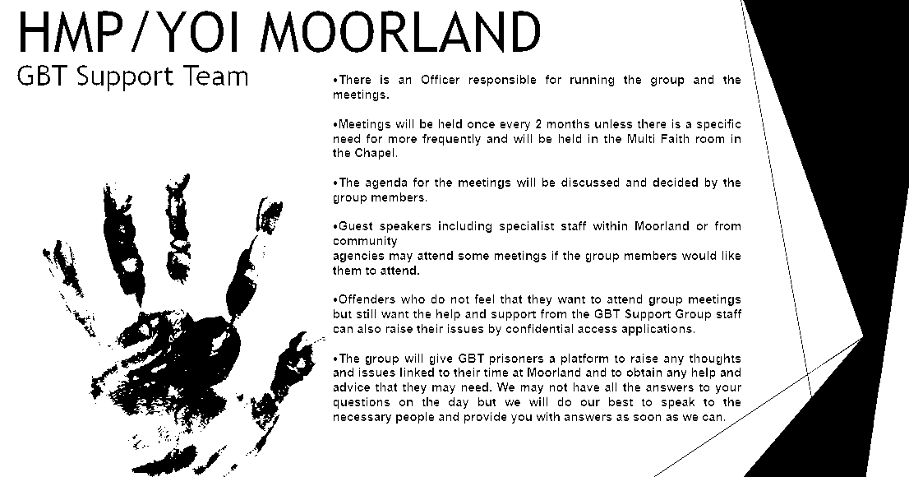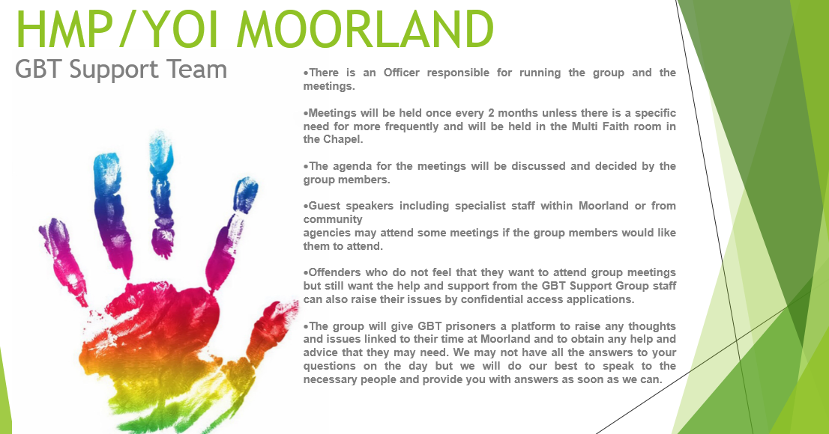

***The top poster is printed the same way as the majority of the posters in the establishment and is harsh and in contrast to the white the passage in the above text becomes apparent –***“**Green** the feeling of **calmness, happiness, comfort, peace, hope**, and **excitement**. And **Black** colour was associated with the feeling of **sadness, depression, fear, and anger**”.

Summery

***In conclusion to this document I would like to thank you for taking your time to read and digest thoroughly and like to finalise by summing up what I think can be achieved by implementing the changes.***

* ***Investing in the suggestions would undoubtedly save on sickness for both staff and prisoners.***
* ***Would result in a decline in Lost Productivity.***
* ***Improve the health and of everybody working and living on Houseblock Seven.***
* ***Has the potential to shorten the Length of time ACCT documents are open.***
* ***Could reduce the number of days Constant watches are active.***
* ***Improving the custodial environment and appearance of the unit.***
* ***Show a willing to embrace change in our views and approach to the management of not just prisoners and staff but the environment we provide to conduct our business.***
* ***To prove how an adequately equipped environment can provide an ambience and backdrop to unconsciously encourage the rehabilitation of prisoner.***
* ***provide a safe secure and decent environment for the process of rehabilitation and provide a climate in which prisoners can progress as individuals ready for their release into the community***

***All of the suggestions above can be achieved with little investment and would provide a long term financial and health benefit to the establishment.***

***If we could prevent one member of staff from going sick for 24 hours or a constant watch could be reduced by just one day the payment plus for that 24 hour period would cover the cost of the purchase of the lights for the centre office and the corridor and still produce a financial benefit.***

***£17 x 24 hours / 6.39 price per tube = 63.85 lighting tubes. There are only 25 tubes needed to cover the centre office and all the landing. Representing a £248.25 profit.***

***I hope you have enjoyed reading this document and have found it informative.***

***As a final note I would like to suggest that the majority of these findings could be applied to all lowly lit areas or areas with no natural light at all and would produce the same benefits to health, loss of productivity, sickness and financial saving.***